**Practical React 1 Exam**

Below is a tree of contacts and groups. A contact has id and name. A group represents a collection of groups/contacts. id is unique across the whole tree

**var *contacts*** = [  
 {  
 **id**:1,  
 **name**: **"Friends"**,  
 **type**: **"Group"**,  
 **contacts**: [  
 {**id**:2, **name**: **"Udi"**, **type**: **"Contact"**},  
 {**id**:3, **name**: **"Tommy"**, **type**: **"Contact"**},  
 {  
 **id**:6,  
 **name**: **"Old Friends"**,  
 **type**: **"Group"**,  
 **contacts**: [  
 {**id**:7, **name**: **"Itay"**, **type**: **"Contact"**},  
 ]  
 },  
 ]  
 },  
 {  
 **id**:4,  
 **name**: **"Family"**,  
 **type**: **"Group"**,  
 **contacts**: [  
 {**id**:5, **name**: **"Roni"**, **type**: **"Contact"**},  
 ]  
 },  
 {**id**: 8, **name**: **"Ori"**, **type**: **"Contact"**},  
];

Your task is to create a React application which displays a tree of contacts and allow the end user to expand each group and see its children items

For example, when running the application all groups are collapsed

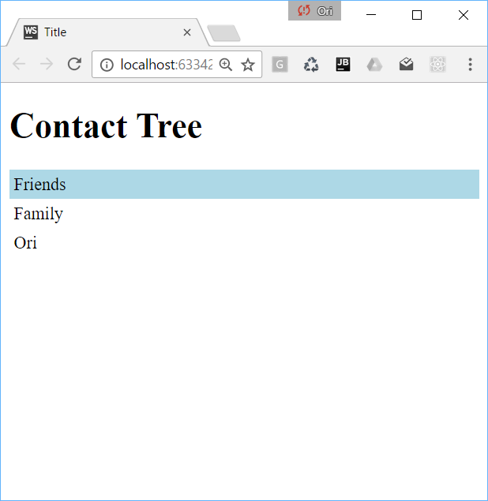

Once the end user clicks the “Friends” group it is expanded as below

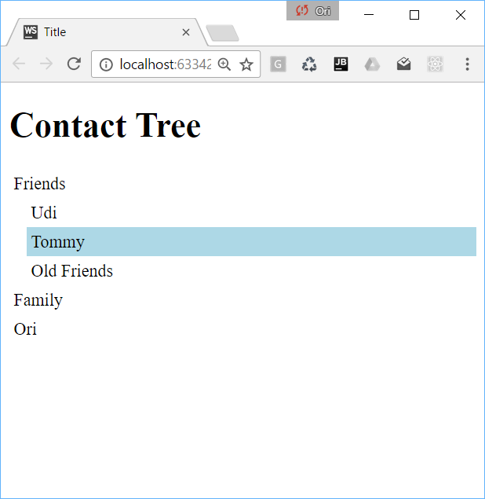

The user can expand any group. This time is the “Old Friends” group

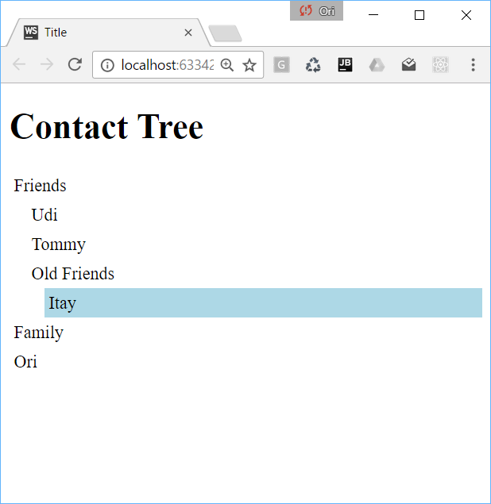

An expanded group can be collapsed by clicking it again

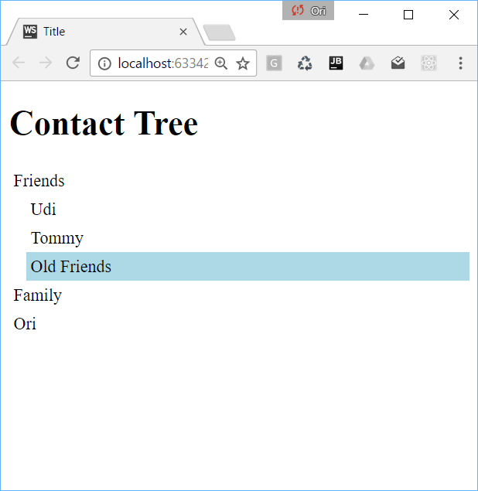

A group that is collapsed should not incur any overhead. That means that a collapsed group’s children are not part of the DOM and are created/destroyed per user click

You should implement the same look & feel (CSS) as described by the screen shots above

You should create a new github repository and send a link to it

Please support the “npm install” and “npm start” so we can easily run your code

Exam time: 1 hour

Can use any internet resource